***DANCIN’ FEET IN MOTION***

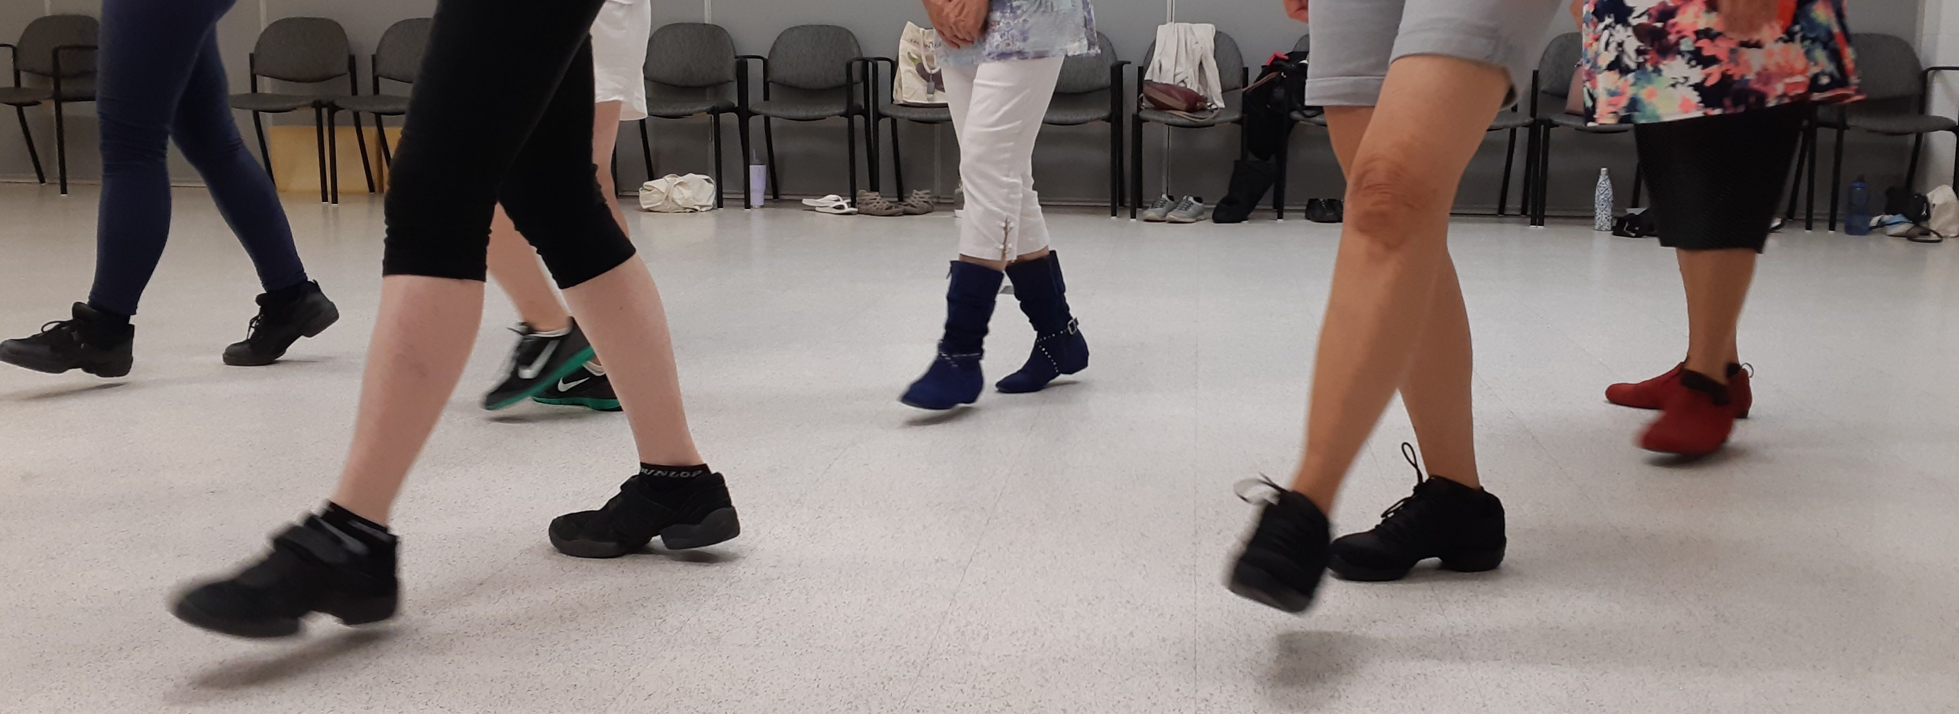

***MODERN LINE DANCE CLASSES!***



*Have FUN while getting/staying FIT!*

**ALL LESSONS HELD AT PARKSIDE CENTRE**

**140 DURHAM ST., SUDBURY (IN THE YMCA BUILDING)**

**First lesson is complimentary. Cost after will be $7 per person, per 1.5-hour lesson, pay as you go (if you don’t attend you don’t pay)**

|  |
| --- |
| **ALL OF THESE CLASSES REQUIRE PREVIOUS LINE DANCE EXPERIENCE**  **Mondays: Seniors’ Only (50 +) – 10:30 a.m. to 12:15 p.m. (over 5 yrs)**  **Mondays: Seniors’ Only (50 + ) – 1:00 p.m. to 2:30 p.m. (since Sept/23)**  **Mondays: Seniors’ Only (50 yrs +) – 2:30 p.m. to 4:00 p.m. (since Jan/24)**  **Wednesdays: Beginner (14 yrs +) – 5:30 p.m. to 7:00 p.m. (since Sept/22)**  **Wednesdays: Beginner (14 +) – 7:00 p.m. to 8:30 p.m. (since Sep/23)**  **Thursdays: Improver / Intermediate (14 yrs +) – 6:30 p.m. to 9:00 p.m.**  **(since forever)** |

**PRE-REGISTRATION IS REQUESTED –**

**CALL OR EMAIL**

**Carol Larocque (Parkside Member) – 705-665-1399**

[**dancinfeetinmotion@gmail.com**](mailto:dancinfeetinmotion@gmail.com)

[**www.dancinfeetinmotion.ca**](http://www.dancinfeetinmotion.ca)